IEEE AESS Summer School

Frontier Technologies for Space 2.0 Communications

6th Edition: University of Rome “Tor Vergata”, Department of Electronic Engineering, Rome (Italy), 14-18 September 2026
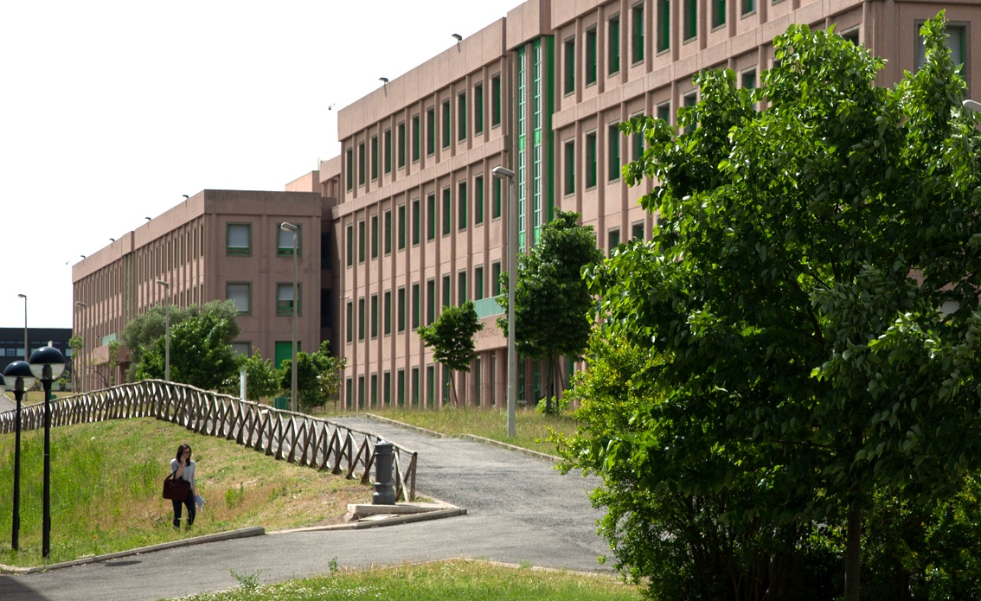

THE SCHOOL IN BRIEF
Since 2021, the IEEE AESS Glue Technologies for Space System technical panel has been organizing the Summer School: “Frontier Technologies for Space 2.0 Communications” with the annual endorsement of IEEE AESS. The coverage of the event is international and gathers students and researchers coming from Europe, the USA, Asia, and Africa. The organizing committee of the school, made up of representatives of the University of Trento, the University of Genoa, and the University of Rome “Tor Vergata,” selected a pool of top-ranked internationally known lecturers, thus producing an exciting final program covering the most advanced and even visionary topics in Space communications and networking. In 2025, the school was revamped, getting support for the organization of a mixed online and in-person event (the in-person part was hosted by the Italian Space Agency), consisting of 30 hours of lectures with interventions from “Glue Tech” panel members and two invited inter-panel lectures dealing with cross-layer ground-breaking aspects about the Space technology of the Future. The new formula was fully successful, collecting 16 students attending in person and 40 students online. In 2026, the IEEE AESS support has been confirmed and, therefore, the successful formula has been reproposed.
The location of the school, for what concerns the in-person part, is, this year, the Department of Electronic Engineering of the University of Rome “Tor Vergata” (Via del Politecnico, snc, Rome, Italy). The University of Rome "Tor Vergata", founded in 1982, is a modern, dynamic public university located in Rome, Italy. Known for strong academic programs and research, it features a large, green, open-concept campus that promotes international learning, sustainability, and professional growth. The university is divided into six main schools offering a wide range of undergraduate and graduate degrees, many of which are taught entirely in English. “Tor Vergata” is highly rated globally for its research and its status among the world's best young universities. It partners with major international organizations, financial institutions, and space agencies, and boasts high employment rates for its graduates.
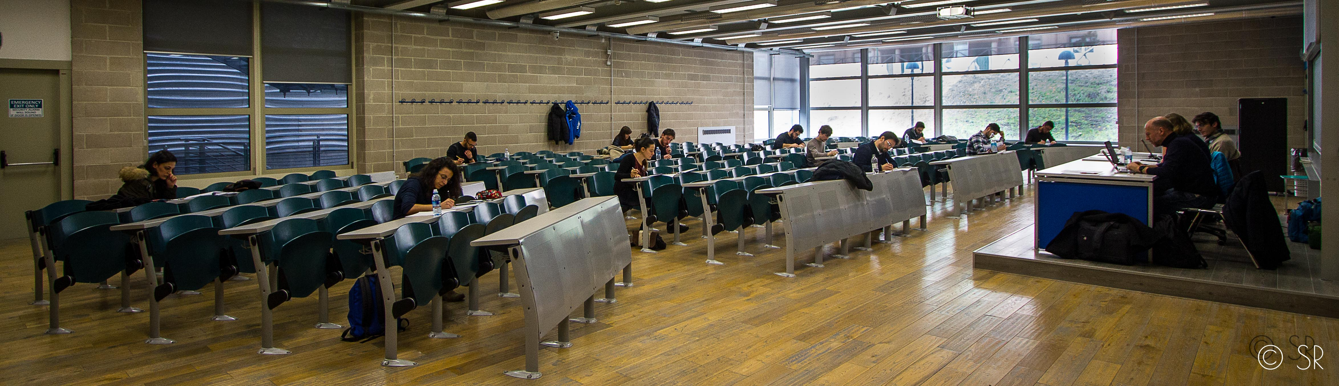
Finally, the school will also represent a unique opportunity to visit Rome, a town that does not need any presentation or explanation. On behalf of the Organizing Committee of the School, I am excited to host you in our School, both in person and online, for an unforgettable week of Science and Culture.

Claudio Sacchi, Chairman of the Summer School organizing committee
Cosimo Stallo, “Glue Tech” panel chair
Ernestina Cianca, Local organizer and “Glue Tech” panel member

School program (version 1.0, draft)

First day: Monday, September 14, 2026
h. 8.45-9.00 a.m. CEST
WELCOME TO THE PARTICIPANTS Claudio Sacchi, University of Trento, Italy, The University of New Mexico, Albuquerque (NM)
h. 9.00-10.15 a.m. CEST
“Space 2.0”: the new Space Revolution EIGHT decades after A.C. Clarke (1st part) (in presence) Claudio Sacchi, University of Trento, Italy, The University of New Mexico, Albuquerque (NM)
h. 10.15-10.45 a.m. CEST
WELCOME COFFEE BREAK
h. 10.50 a.m. - 12.05 p.m. CEST
“Space 2.0”: the new Space Revolution EIGHT decades after A.C. Clarke (2nd part) (in presence) Claudio Sacchi, University of Trento, Italy, The University of New Mexico, Albuquerque (NM)
h. 12.10 – 2.00 p.m. CEST
LUNCH BREAK
h. 4.00 – 6.30 p.m. CEST
End-to-end engineering approach for Space Systems (online), Kar-Ming Cheung, Jet Propulsion Lab (JPL) of NASA, Pasadena (CA)

Second day: Tuesday, September 15, 2026
h. 9.00 – 11.00 a.m. CEST
Space Softwarization: from Physical Layer to Services (1st part) (mixed) Fabrizio Granelli, Claudio Sacchi, University of Trento, Italy, The University of New Mexico, Albuquerque, NM, Alessandro Guidotti, University of Bologna, Italy.
h. 11.00 – 11.30 a.m. CEST
COFFEE BREAK
h. 11.30 a.m. – 12.30 p.m. CEST
Space Softwarization: from Physical Layer to Services (2nd part) (mixed) Fabrizio Granelli, Claudio Sacchi, University of Trento, Italy, The University of New Mexico, Albuquerque, NM, Alessandro Guidotti, University of Bologna, Italy.
h. 12.35 – 2.00 p.m. CEST
LUNCH BREAK
h. 2.15 – 4.00 p.m. CEST
EXTRATERRESTRIAL AND INTERPLANETARY COMMUNICATIONS: WILL BE “FIELD” ON MARS? Claudio Sacchi, University of Trento, Italy, The University of New Mexico, Albuquerque, NM.

Third day: Wednesday, September 16, 2026
h. 9.00 a.m. – 11.00 a.m. CEST
INVITED LECTURE #1 – Securing Space 2.0: Building Cyber Resilience for Connected and Intelligent Space Systems (in person) Kendra Cook, SAIC, Reston, VA.
h. 11.00 – 11.30 a.m. CEST
COFFEE BREAK
h. 11.30 a.m. – 12.30 p.m. CEST
Guided visit to the Italian Space Agency
h. 12.35 – 2.00 p.m. CEST
LUNCH BREAK (in ASI premises)
h. 2.30-5.30 p.m. CEST
Satellite Networking in “5G and beyond” scenarios, (mixed) Mario Marchese, Fabio Patrone, University of Genoa (Italy), Mohammed Slim Alouini, King Abdullah University of Science and Technology – KAUST, Kingdom of Saudi Arabia

Fourth day: Thursday, September 17, 2026
h. 9.00 a.m. – 10.30 a.m. CEST
EHF for satellite communications: the latest developments (1st part) (in presence), Giuseppe Codispoti (ASI), Giorgia Parca, ASI, Italy, Tommaso Rossi, University of Rome “Tor Vergata”, Italy.
h. 10.30 – 11.00 a.m. CEST
COFFEE BREAK
h. 11.00 a.m. – 1.00 p.m. CEST
EHF for satellite communications: the latest developments (2nd part) (in presence), Giuseppe Codispoti (ASI), Giorgia Parca, ASI, Italy, Tommaso Rossi, University of Rome “Tor Vergata”, Italy.
h. 1.00 p.m. – 2.30 p.m. CEST
LUNCH BREAK.
h. 3.00 p.m. – 5.00 p.m. CEST
INVITED LECTURE #2 – EXTRA TERRESTRIAL NAVIGATION AND COMMUNICATION (in presence) Cosimo Stallo, ESA, UK.

Last day: Friday, September 18, 2026
h. 10.00 – 11.15 a.m. CEST
Reconfigurable Intelligent Surface (RIS) and Software-Defined Radio (SDR) technologies as key enablers of secure and efficient NTN transmission, (1st part) (in presence) Ivan Iudice, Italian Center of Aerospace Research (CIRA), Capua, Italy.
h. 11.15 – 11.35 a.m. CEST
COFFEE BREAK
h. 11.35 a.m. – 1.00 p.m. CEST
Reconfigurable Intelligent Surface (RIS) and Software-Defined Radio (SDR) technologies as key enablers of secure and efficient NTN transmission, (2nd part) (in presence) Ivan Iudice, Italian Center of Aerospace Research (CIRA), Capua, Italy.
h. 1.00 p.m. – 2.30 p.m. CEST
LUNCH BREAK.
h. 2.30 – 4.30 p.m. CEST
INVITED LECTURE #3 – TOWARD SECURE AND SUSTAINABLE NON-TERRESTRIAL NETWORKS (in presence) Gunes Karabulut Kurt, Polytechnique Montreal, Montreal (CAN).
h. 4.30 p.m. – 4.45 p.m. CEST
SCHOOL CONCLUSION, Claudio Sacchi, University of Trento, Italy, The University of New Mexico, Albuquerque (NM)

School lectures and credits
The lectures will be held in mixed modality: in person for the students physically attending the “Tor Vergata” room and online for the students connected remotely. A Zoom link, managed by IEEE AESS, will be sent to the online students. The lectures will be recorded. For those students who want to earn credits, an online test will be administered after the end of the lectures.

Registration
The registration for the school is FREE. Prospective students should register by completing the online registration form available soon on the AESS website at https://ieee-aess.org/. For any information, please send an email to: claudio.sacchi@unitn.it
Mandatory registration deadline: AUGUST 30, 2026.

How to reach “Tor Vergata”
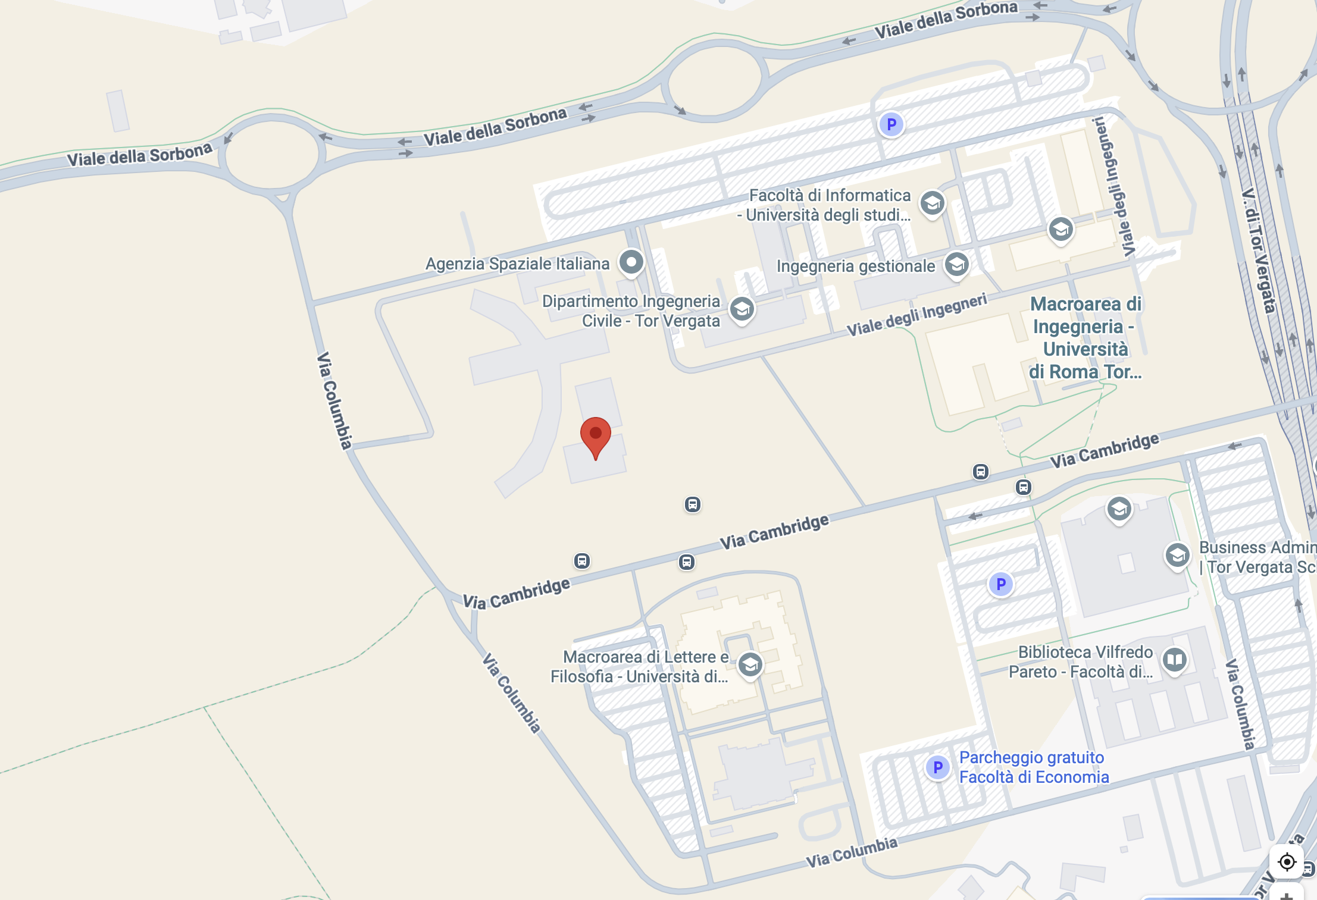
The University of Rome “Tor Vergata” is in Via del Politecnico snc in Rome, in the scientific area of “Tor Vergata” quarter. The area is about 15 Km far from the center of Rome. The instructions to reach the school location are detailed in the following:
- From Roma Termini: Metro line A to Anagnina, then autobus n. 20 and stop at Via Cambridge station.
- From Fiumicino Aeroporto: train to Roma Termini, Metro line A to Anagnina station, then autobus n. 20 to and stop at Via Cambridge station.
The C8 room will host the lectures.

